Working on IAM
Working on IAM (Identity and Access Management) involves creating and managing users, roles, and permissions to securely control access to AWS services and resources. The main purpose of IAM is to ensure that only authorized users can access specific resources based on their roles and responsibilities.
It allows administrators to assign policies, manage credentials, and implement security practices such as least privilege, where users are given only the permissions they need. IAM also helps avoid the use of the root account for regular tasks, improving overall account security.
By using IAM effectively, organizations can protect their data, reduce security risks, and maintain proper control over who can access and modify AWS resources.
Step 1 : IAM Dashboard
The IAM Dashboard is the main interface for managing access and security in AWS. It allows users to create and manage IAM users, roles, and permissions. From this dashboard, you can view security status, apply policies, and control who has access to AWS resources. It also
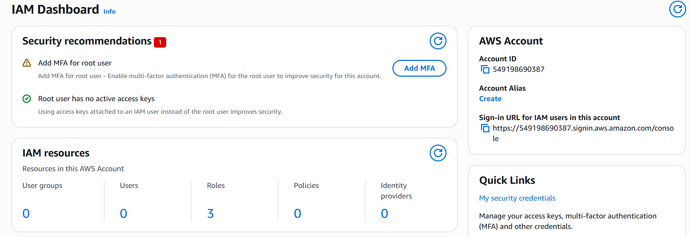
Step 2 : Creating a User
This step involves creating a new IAM user to provide access to AWS resources. A unique username is assigned, and the type of access (programmatic or console) is selected. It ensures that individuals can securely access the AWS account with specific credentials instead of using the root account.
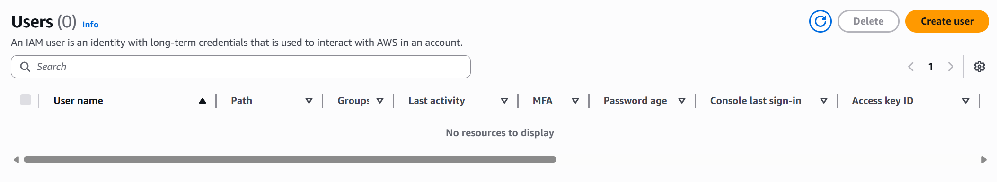

Step 3 : Naming the User and Configuring Settings
In this step, a username is assigned and access settings are configured. The Provide user access option is enabled to allow the user to log in to AWS. Under permissions, the Attach policies directly option is selected to assign specific policies to the user, defining what actions they can perform on AWS resources
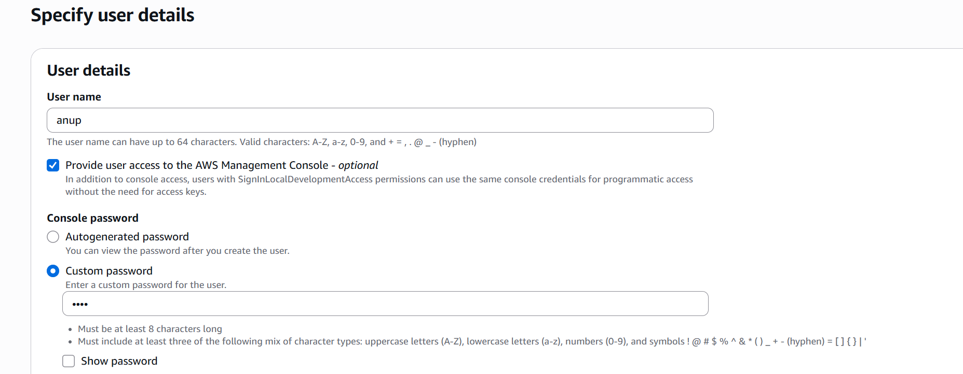

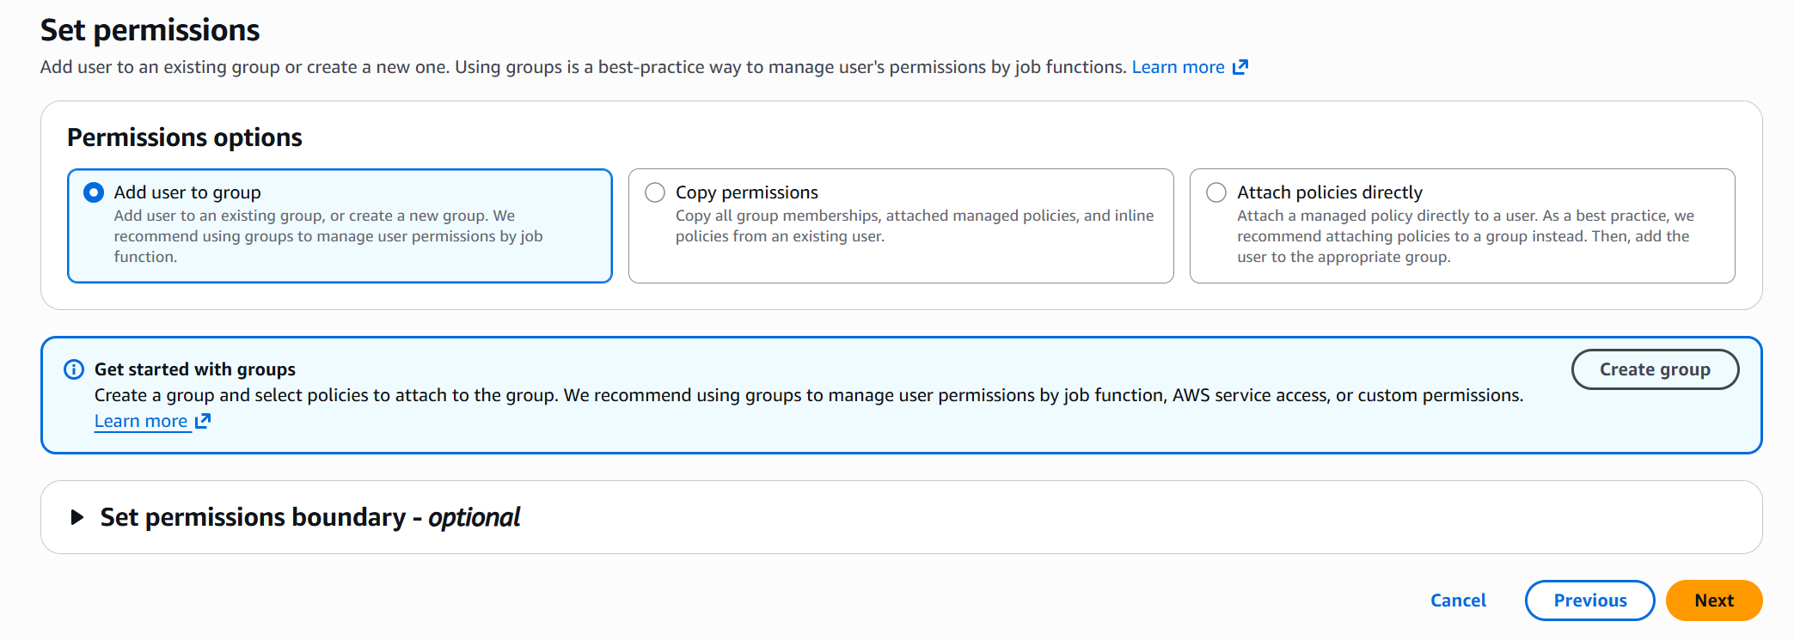

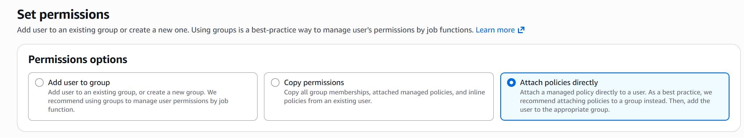
Step 4 : Selecting Permission Policy
In this step, the AmazonS3FullAccess policy is selected from the permissions list. This policy grants the user full access to Amazon S3 services, allowing them to create, view, edit, and delete S3 resources. Assigning this policy ensures the user has complete control over S3 operations within the AWS account.
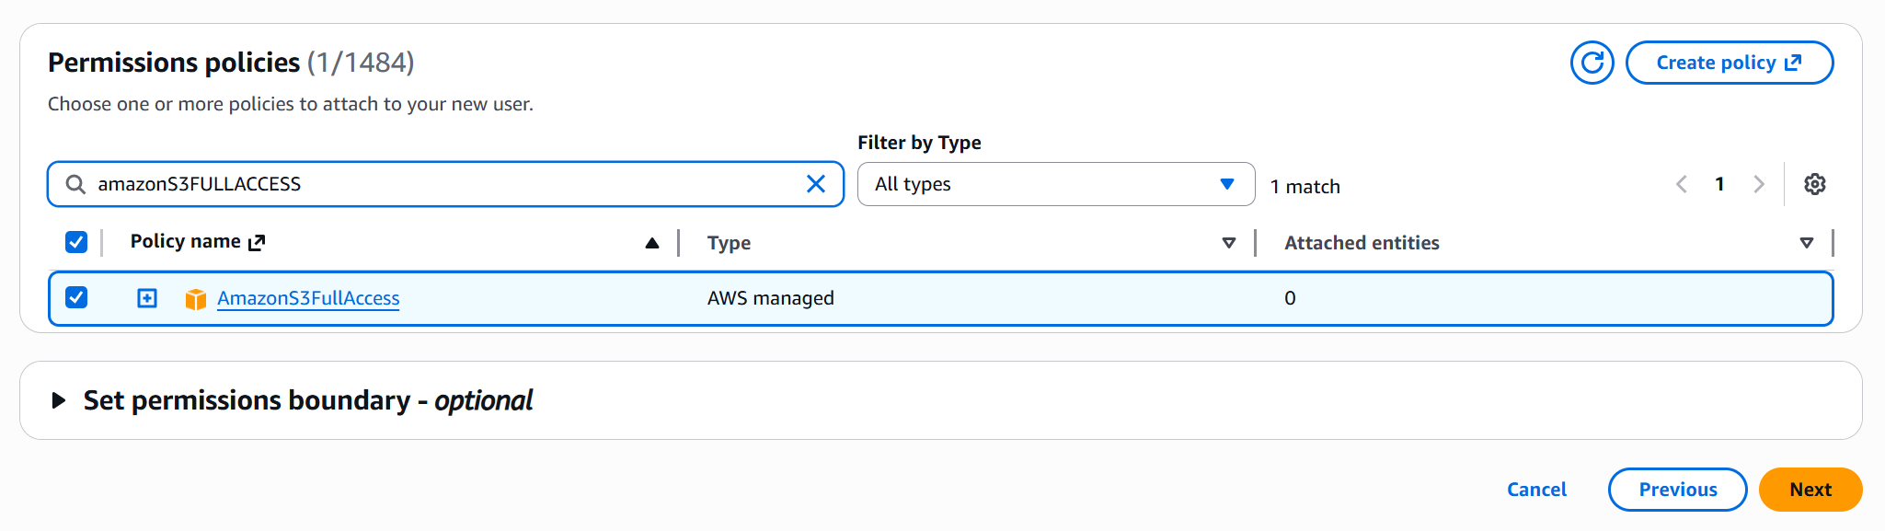
Step 5 : Review and Create User
In this step, all the configured details are reviewed before creating the user. This includes the username, selected permissions (policies), and any tags added. The permissions summary provides a clear overview of access rights assigned to the user. After verifying the details, the user is created successfully.
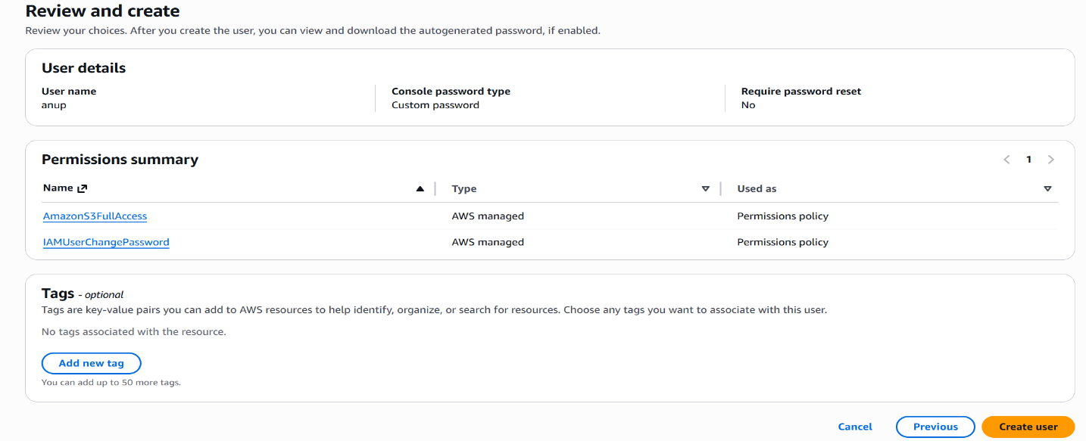
Step 6 : Retrieving Password and Sign-In Details
In this step, the login credentials for the IAM user are displayed. This includes the console sign-in URL, username, and password. These details are used by the user to access the AWS Management Console. It is important to store this information securely or download it for future use
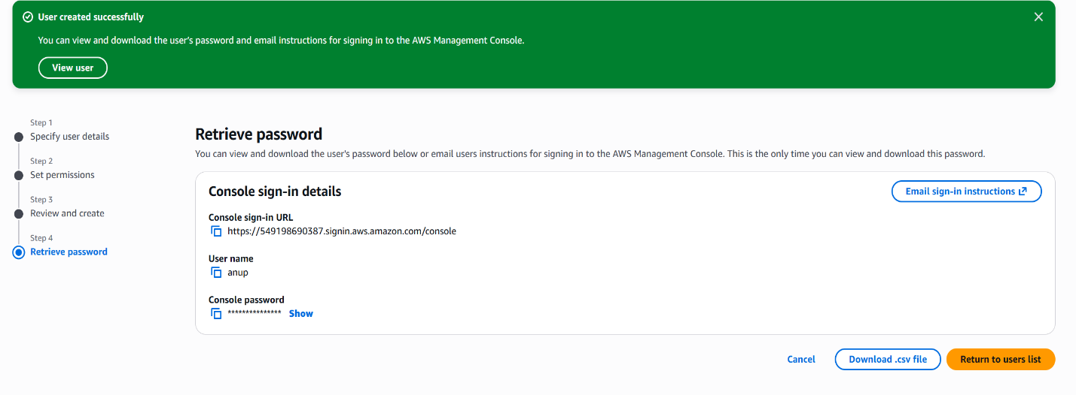
Step 7 : Sharing Sign-In Details
The sign-in URL is shared with the user. The user is instructed to open the link in an incognito window or a different browser and log in using the provided username and password. This ensures secure access and prevents conflicts with existing AWS sessions.
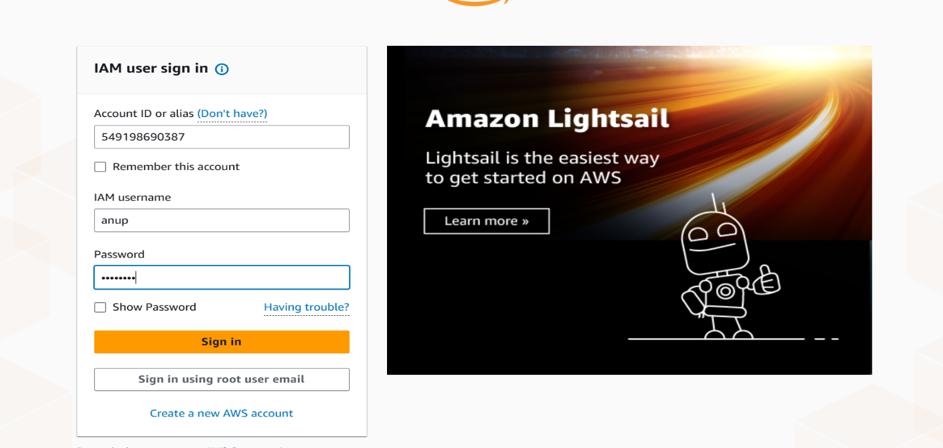

Step 8 : AWS Console Home (Incognito Mode)
In this step, the IAM user successfully logs into the AWS Management Console using the provided credentials in an incognito window. The Console Home page is displayed, showing access to various AWS services. This confirms that the user account has been created correctly and is able to access the assigned resources
